Guidance for the recording of UCL PhD/MPhil vivas
using Microsoft Teams.

7 May 2020

With the current pandemic situation, PhD vivas are either being postponed or are being held using video systems such as Microsoft Teams. The UCL Doctoral School strongly recommends that these "virtual" vivas should be recorded but not mandatory. This is to ensure that this unusual viva format is running satisfactorily, and also for use in the unlikely event of queries or complaints about technical or procedural problems with a viva.

Teams recordings should be stored securely in Microsoft Stream until the student is awarded their degree, at which point they must be deleted.

- Where a recording is planned, the supervisor must ask the viva attendees ahead of time for their consent. If consent is not given, this should be made clear to everyone beforehand and the recording should not be made.

- It is also very important that supervisors notify their DGT of an upcoming viva well ahead of time, to make sure everything is correctly in place for the viva and its recording.

- To plan for the recording of a viva, the organiser should first generate a calendared Meeting in Microsoft Teams.

- When the meeting starts and the recording is started, this action is flagged up to all participants and by continuing in the viva the participants are giving tacit approval to the recording. The recordings are stored securely in Stream, which is GDPR-compliant.

- The Faculty recommends that the person physically starting the recording is also the Organiser of the Teams meeting. This person should be:

- Preferably the internal examiner, or
- The DGT if there are two external examiners (or the supervisor here if the DGT is not available). N.B. Both the DGT and supervisor can start the recording but should thereafter be silent observers if they remain in the viva and they should not chair it.

- Also highly recommended is a full test of the Teams connections ahead of time with everyone involved, to make sure everyone can join, leave, record and re-join the meeting
- If a viva starts and the recording interferes with the meeting (recording does put a bit more strain on bandwidth and the recorder’s computer), then we advise that the recording is stopped and, if the meeting is otherwise technically sound, either:
(i) another meeting member tries recording, or
(ii) continuing the viva without recording

- The recordings must be treated at highly confidential

- The DGT gives the ultimate request for and confirm of the deletion the recording, once any appeals processes are finished and the student has been awarded their degree. It may be easiest to ask the student directly if they are happy for the recording to be removed post-award.

- These additional technical points:
- Once a person (any UCL member at the meeting; not Guests) starts the recording then no-one else can record at the same time.
- The person starting the recording is an “Owner” of the recording
- If the person recording is not the meeting organiser, then the organiser is also a co-owner of the recording. Thus, it is preferable for the Internal examiner (or DGT as above) to both organise the viva meeting and record it him/herself, thus generating simply one Owner
- After the viva, recordings are stored securely on Microsoft Stream. In addition, Teams provide a downloadable link of the recording in the Meeting Chat, to only those attending the viva.
- The Owner also receives an email with a Stream link from where they can control access permissions to the recording.
  - For example an Internal examiner may need to grant access to a UCL DGT after the viva (see below for instructions).
  - DGTs may use these shared links to keep track of recordings and to make sure they are ultimately deleted
- Those external to UCL (Guests) cannot get immediate access to a recording, even if they were in the meeting
  - If the external examiner were to need access (this should be a rare occurrence), the Owner should download the recording and make it accessible securely via either UCL Dropbox or from a shared file in OneDrive for example
  - However, these recordings generate very large files (1hr recording = about 500Mb). Recordings can also be converted to audio-only using Quicktime, reducing file size by 90%.
- If the organiser is either the DGT or supervisor, they might only start the recording and then leave the meeting. In this case:
  - Recordings continue even if the person starting the recording leaves the meeting.
  - The recording stops automatically once all participants have left the meeting.
  - A copy of the recording is sent as usual to the original recorder of the meeting via Microsoft Stream.
---

These resources help to explain in further details how to record Teams meetings and change permissions on a video in Stream:
Recording in Microsoft Teams guidance
Play and share a meeting recording
Delete a meeting recording
Edit a recording transcript
---

How to provide a DGT with access to the recording

If requested, the Owner should share the Stream recording with a DGT by first opening the video in Stream and then doing the following:
- click on the "add to group/channel" icon

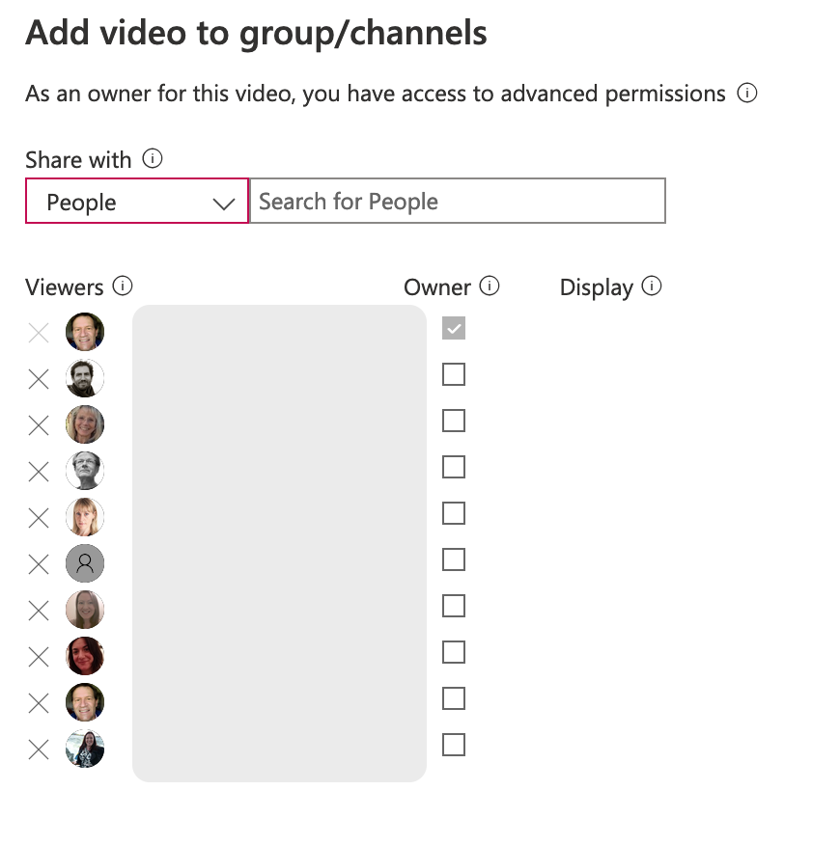
- then choose People in the dropdown menu
- then search the name of the UCL person to share the video with; this should locate their email address and you should click on this
- This person then has access to the Streams recording
- Once added, you should tick the ‘Owner’ box next to the DGT name – this will give then permission to delete the recording once no longer needed.

